**MCAN IA2 - Android App Report**

**Recording Voice and Converting to Transcript**

**Abstract**

Speech is the first important primary need, and the most convenient means of communication between people. The communication among human computer interaction is called human computer interface. Speech recognition technology is one of the fastest growing engineering technologies. The project is capable of recognizing the voice and converting this voice input into transcripts.

**Introduction**

* **Motivation (Need of project)**

Students spend a lot of time making notes for their lectures. They are not the only ones with this problem though - academics and researchers, journalists, and even people who attend a lot of meetings and need to keep everything organised end up with a long transcription queue at some point of time or the other. Nearly 20% of people in the world are suffering from various disabilities. Many of them are unable to use their hands effectively to write or type text.

* **Problem definition**

Students, academics and researchers, journalists, and even people who attend a lot of meetings and need to keep everything organised end up with a long transcription queue and spend a lot of time writing notes and transcripts. Our normal workflow to deal with this has been to keep the audio file playing in the background, as we type in a text editor. There are a couple of obvious problems with this - for one, things like pausing and moving back and forward are needlessly complicated as you move between programs, and for another, controlling playback speed to suit your typing speed isn't easy either. In short, it's a really bad workflow. As a result, we're always on the lookout for a good app that can solve this problem because it would make life a lot easier - in one instance where we actually resorted to getting someone to help transcribe a book's worth of lecture notes.

* **Scope**

While speech-to-text used to be specifically only for desktops, the development of mobile devices and the explosion of easily accessible apps means that transcription can now be carried out on a smartphone or tablet. This has made speech-to-text applications increasingly valuable to users in a range of different environments, from education to business. This is not least because the technology has matured to the level where mistakes in transcriptions are relatively rare, with some services rightly boasting a 99.9% success rate from clear audio. The android app can be used by the students to listen to the audio lectures as well as to refer to the transcribed notes. It can also be used by people with disabilities to share information with people through voice input.

**Implementation**

* **System Architecture**

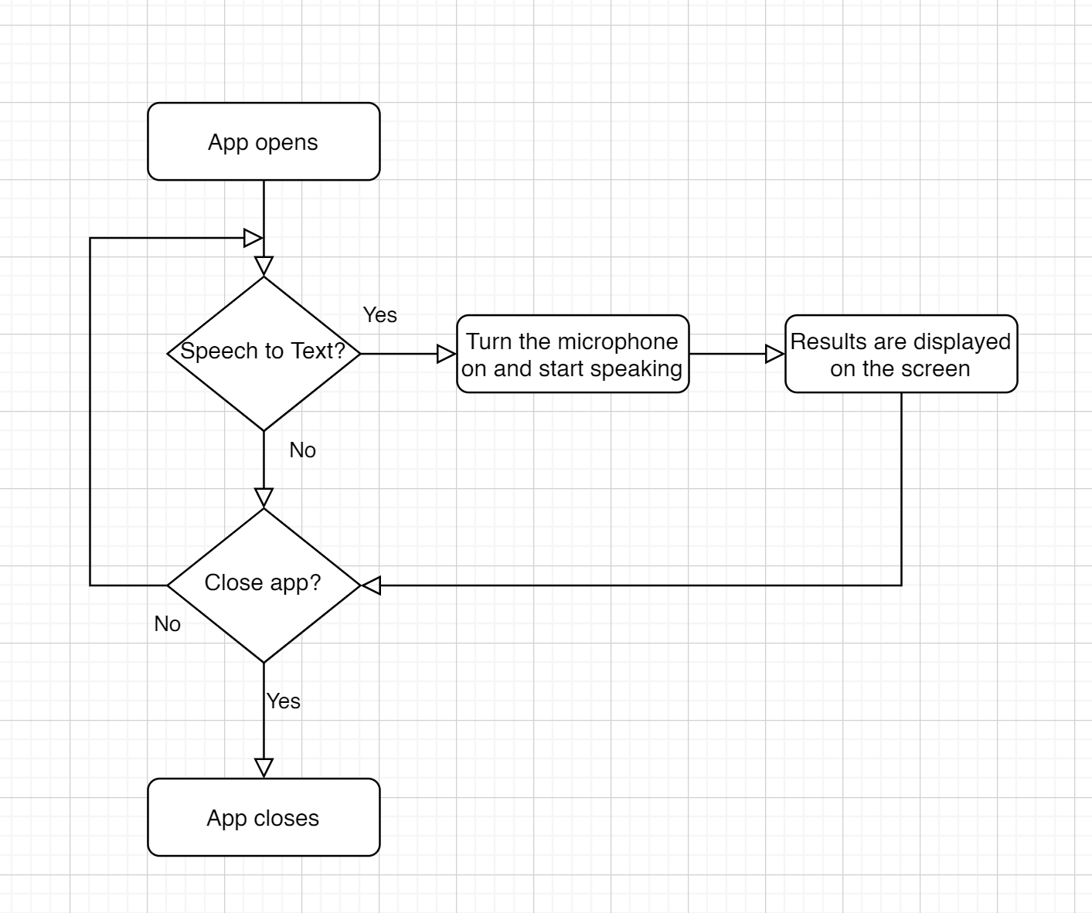

* **APIs used (and Hardware Requirements if any)**

Flutter plugin speech_to_text version 0.3.0+1 .Microphone is the only hardware requirement needed.More about the dart package can be found on <https://pub.dev/packages/speech_to_text>

* **Working with Screenshots**

A library that exposes device specific speech recognition capability.This plugin contains a set of classes that make it easy to use the speech recognition capabilities of the mobile device in Flutter. It supports both Android and iOS. The target use cases for this library are commands and short phrases, not continuous spoken conversion or always on listening.

Usage:

To use this plugin, we add audio_recorder as a [dependency in your pubspec.yaml file](https://flutter.io/platform-plugins/).

Android:

We add the following permissions to your Android Manifest

<uses-permission android:name="android.permission.RECORD_AUDIO" />

<uses-permission android:name="android.permission.WRITE_EXTERNAL_STORAGE" />

iOS:

We add the following key to Info.plist for iOS

<key>NSMicrophoneUsageDescription</key>

<string>Record audio for playback</string>

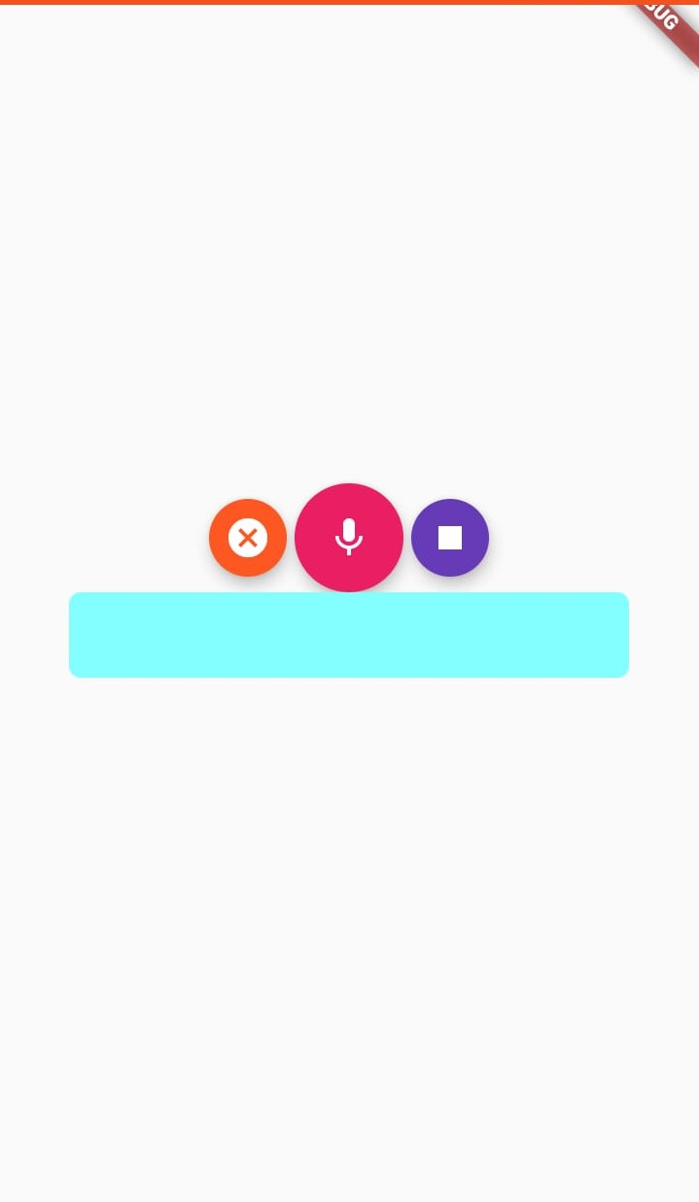

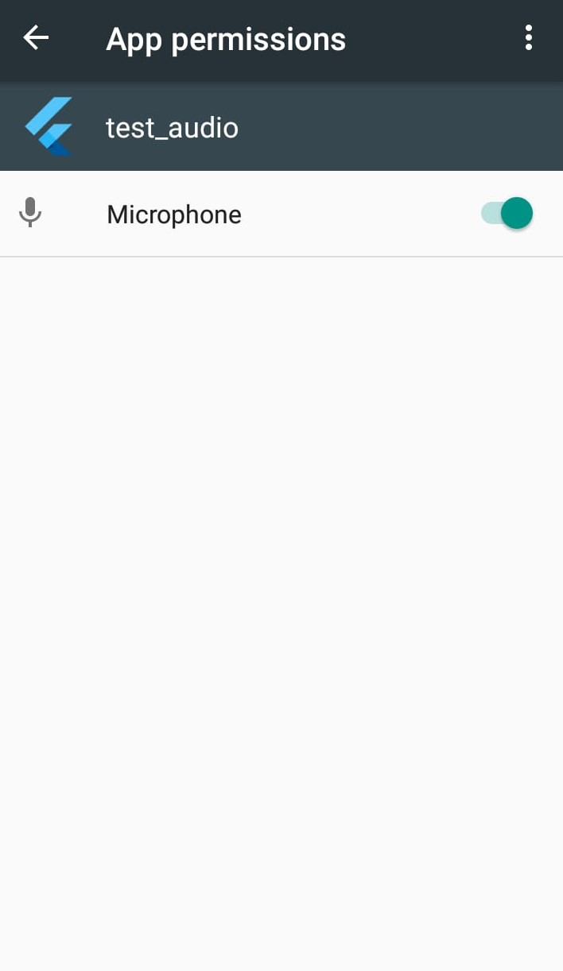

* **Results**

The android application for recording voice and converting to transcripts was created using flutter and was tested.

**Conclusion**

Hence an speech to text application for both android and ios was developed.

**References**

1. *B. Raghavendhar Reddy, E. Mahender, “Speech to Text Conversion using Android Platform”, International Journal of Engineering Research and Applications (IJERA) Vol. 3, Issue 1, January -February 2013, pp.253-258*
2. *Prachi Khilari, Prof. Bhope V. P, “Implementation of Speech to Text Conversion”, International Journal of Innovative Research in Science, Engineering and Technology Vol. 4, Issue 7, July 2015*
3. [*https://www.amberscript.com/en/blog/how-s-and-why-s-behind-speech-to-text*](https://www.amberscript.com/en/blog/how-s-and-why-s-behind-speech-to-text)

**Appendix**

* **User Manual**

Download the app using the apk file. The app opens and asks for permission to allow the use of microphone. Permit the use of microphone by selecting yes. If you want your speech to be converted to text then click on the microphone button and start speaking. If you want to stop recording then click on the right stop button. If you wish to cancel your last speech, click on the left cross button.